Lesson Plan: Writing Effective AET Journal Entries
Course: Agricultural Education / SAE Recordkeeping
Grade Level: 9–12
Time Required: 1 Class Period (45–60 Minutes)
Topic: Writing and Reflecting in AET Journals for SAE, FFA, and Community Service Activities
Standards Alignment
AFNR Career Ready Practices
- CRP.02: Apply appropriate academic and technical skills.
- CRP.04: Communicate clearly, effectively, and with reason.
- CRP.05: Demonstrate productivity and accountability.
- CS.09: Apply leadership and personal development skills in agricultural contexts.
- CS.06: Evaluate the role of agriculture, food, and natural resources systems in society and the economy.
FFA Standards
- Maintain accurate, current SAE records.
- Reflect on learning, growth, and leadership development.
- Connect classroom, FFA, and work-based learning experiences.
ELA Integration (CCSS)
- CCSS.ELA-LITERACY.W.9-10.2: Write informative/explanatory texts to convey complex ideas clearly and accurately.
Learning Objectives
By the end of this lesson, students will be able to:
1. Identify the purpose and structure of an AET journal entry.
2. Distinguish between SAE, FFA, and Community Service entries.
3. Write a complete, accurate, and reflective AET journal entry using appropriate grammar and detail.
4. Evaluate their own writing using the AET Journal Entry Rubric
5. Explain how maintaining accurate journal records supports career readiness and employability.

Connection to the World of Work & Career Readiness
- AET Journals mirror professional workplace documentation. Employers value employees who can clearly and accurately report time, outcomes, and progress.
- Recording SAE, FFA, and service activities builds accountability, organization, and reflection skills needed in all careers.
- Journals help students articulate transferable skills (leadership, time management, communication) for job interviews, FFA degree applications, and resumes.
- Accurate recordkeeping supports college and scholarship applications, FFA awards, and professional networking opportunities.

Materials Needed
- Computers or tablets with AET access
- Projector or smartboard
- Example AET journal entries (strong and weak models) - ATTACHMENT !
- AET Journal Entry Rubric (25 points)
- AET Self-Assessment Checklist - ATTACHMENT 2
- Notebook paper or digital writing platform (Google Docs, LMS submission area)

Lesson Procedures

1. Bell Ringer (5–7 Minutes)
Prompt:
“Think about something you did recently for your SAE, FFA, or community service. In 2–3 sentences, describe what you did and what you learned.”
Students should write a response on a sheet of notebook paper
Discussion:
1. Why might this information be valuable later?
- Student Reports: Journal Reports, Competency Mastery Reports, Degree and Award Application verification
- Chapter Reports: Economic Impact Report, AFNR Skill Development Report, Journal Reports
- State Education Reports: Work-Based Learning Reports
Resource: AET/Reports TAB (Student & Teacher) 
2. How do professionals keep records of their work?
- Log Books: Truckers, Cosmetologists, Lawyers, Researchers, Medical professionals
- Invoices: Services, Sales, Labor provided
- Inventory: Production, Military

3. Can you name a profession that does not require documentation or record-keeping?
- Does not exist:
a. Surfers: record weather conditions, board length, body weight, entries
b. Digital Gamers: Competitor names, game features/challenges, earnings, tax reports
c. Doctors/Nurses: My Chart information of patient vitals, health history, etc
Lead into: “Your AET journal is your professional record — your résumé in progress.”

2. Direct Instruction (10–12 Minutes)
Teacher Presentation & Discussion:
- Define AET Journals and their purpose.
Who can define a journal?
Allow students to provide a variety of answers.
Definition:

A journal is a written record of experiences, activities, observations, and reflections that is kept over time to document what was done, what was learned, and why it matters.

In an educational and career-readiness context (like AET, SAE, FFA, or community service), a journal:
- Records dates, tasks, and time spent
- Describes skills practiced and outcomes
- Reflects on learning, growth, and improvement
- Serves as evidence of responsibility, progress, and professional development
Simple student-friendly definition:

A journal is a place to write down what you did, what you learned, and how the experience helped you grow.
World-of-work connection:
Journals are similar to work logs, reports, or professional documentation used by employers to track performance, accountability, and skill development.
- Discuss the 3 main types of entries:
• FFA Entries: Meetings, contests, officer duties, leadership events.
• Community Service Entries: Volunteer work, civic projects, service learning.
- SAE Entries: Work hours, responsibilities, financial data, skills learned.

KEY Helpful Tips:
 Allow students to hover over green question marks to reveal tips and examples for components of a journal entry
- Journal Sample Entries (strong vs. weak)
- Review the AET Journal Rubric and categories:
1. Completeness 2. Reflection and Learning 3. Professionalism and Clarity
- Use Self-Assessment Checklist categories:
Date, Category, Group Served, Skill Area, Activity Description, Time, Photos

3. Guided Practice (15 Minutes)
Activity:
Students log into AET and draft one journal entry about a recent activity.
- Teacher models writing process step-by-step.
- Students use the rubric and checklist to ensure all components are included.
- Teacher circulates, giving targeted feedback on clarity and reflection.
Optional: Peer review using the Self-Assessment Checklist.

4. Independent Practice (10–15 Minutes)
Students finalize their journal entry and input it into AET.
They then complete the self-assessment checklist and submit both:
- Screenshot or copy of AET entry
- Completed checklist for grading and feedback

5. Closure (5 Minutes)
Class Discussion:
“Why are AET journals more than just recordkeeping? How do they prepare you for your future career?”
Teacher Summary:
- Good journal entries show growth, responsibility, and employability.
- Clear writing = clear thinking = career readiness.
- Regular and quality AET records help earn FFA degrees, awards, and scholarships more efficiently during award season.

Assessment
Formative:
- Participation in discussion and guided practice
- Draft journal entry feedback
Summative:
- Final AET journal entry scored using AET Journal Entry Rubric (25 pts)
- Completed Self-Assessment Checklist

Differentiation
- For Beginners: Provide sentence stems and model examples (“Today I learned that…”).
- For Advanced Students: Require deeper reflection on technical skills or career connections.
- For Accommodations: Allow voice-to-text dictation, extended time, or verbal reflection in AET.

Extension & Enrichment
- Write a monthly reflection summary analyzing progress and skill development.
- Generate an AET report to show cumulative learning or work hours.
- Connect entries to FFA Proficiency Awards, Degrees, or Career Portfolios.

Teacher Notes
✔ Reinforce AET as a career record system, not just a school requirement.
✔ Encourage students to update entries weekly to prevent backlogging.
✔ Integrate career discussions: “What would this journal entry show an employer about your reliability?”
✔Implement an accountability system each grading period for all journal types

Journal Sample Entries: ATTACHMENT 1
Community Service - High Quality
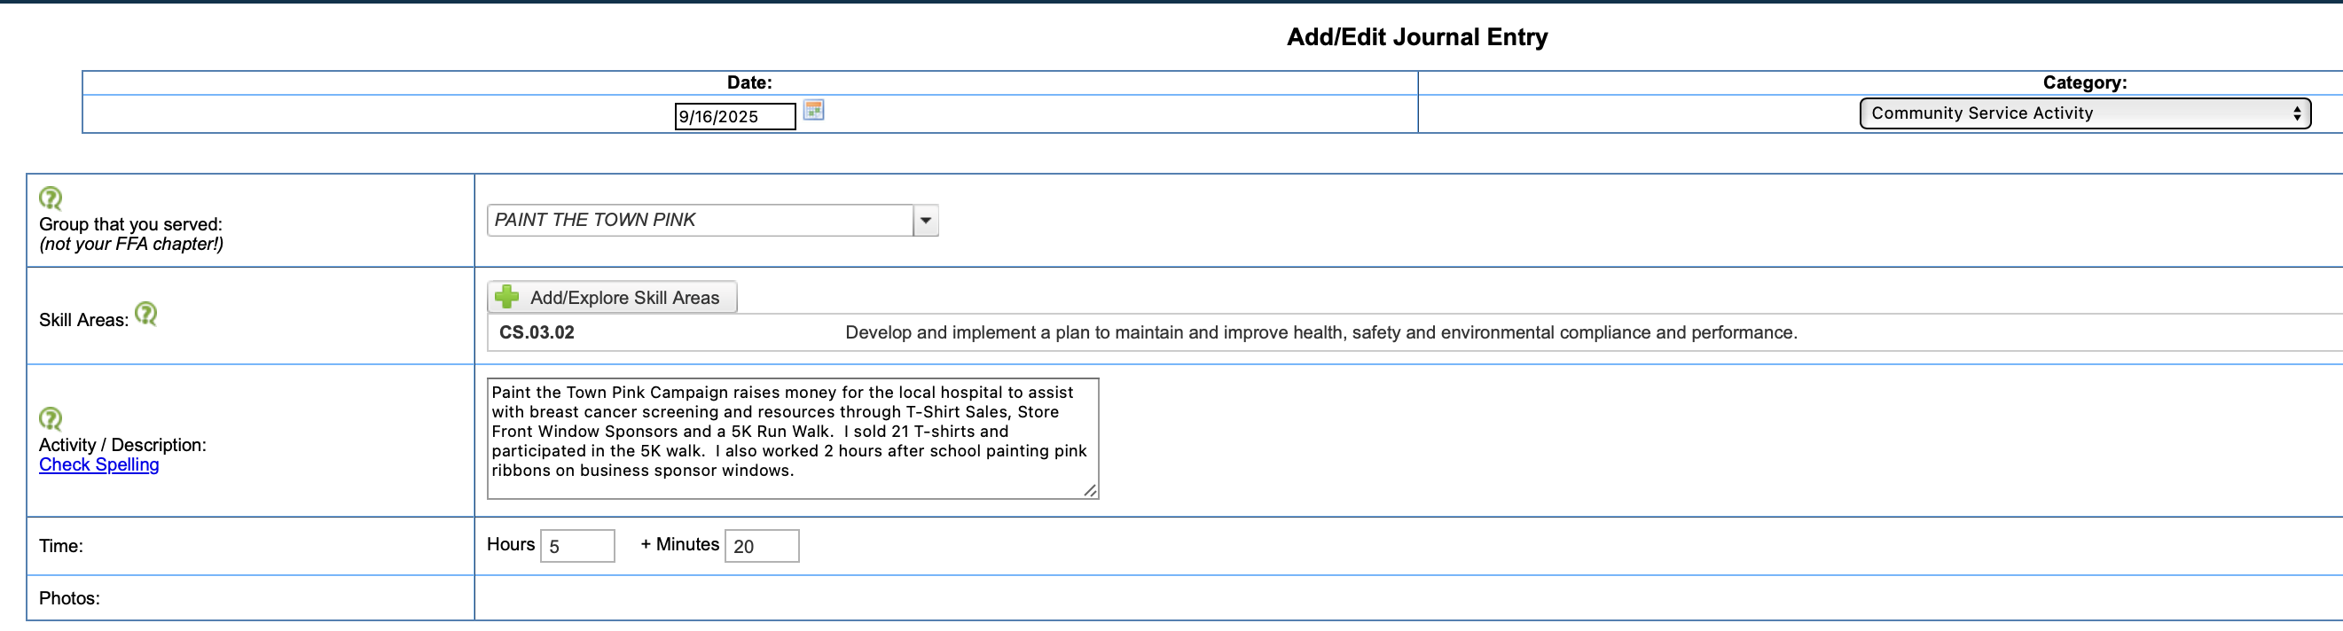
Community Service - Low Quality 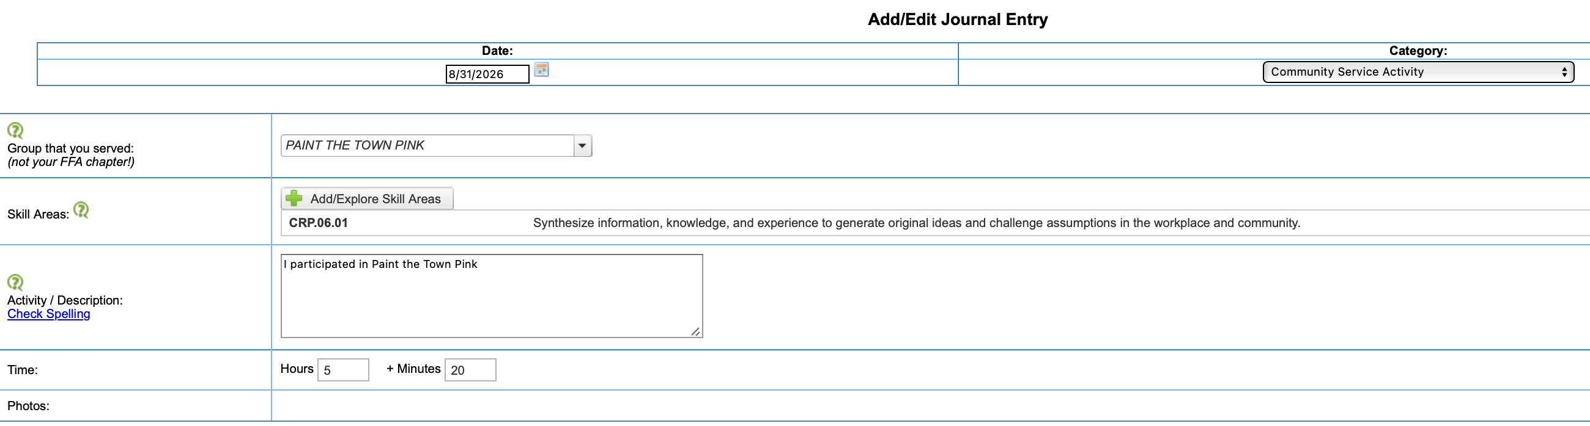
FFA Competition - High Quality
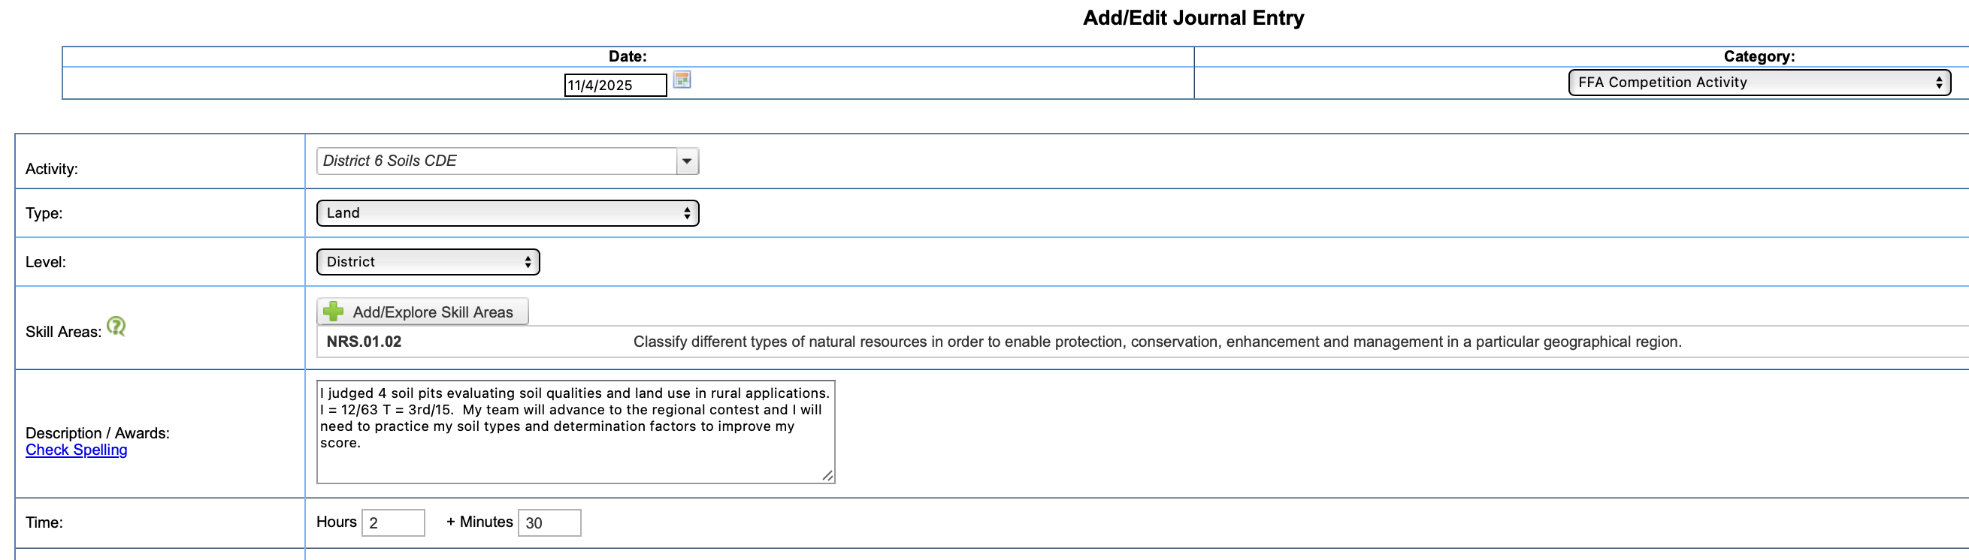

FFA Competition - Low Quality
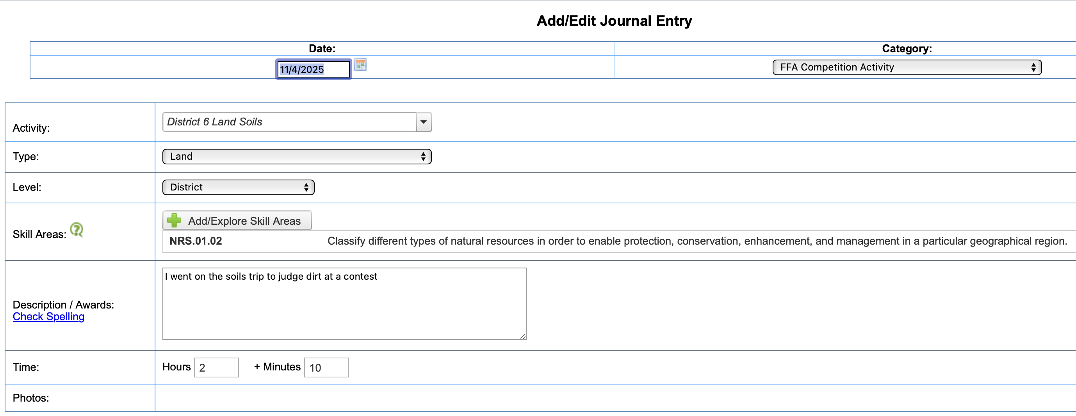

SAE - High Quality
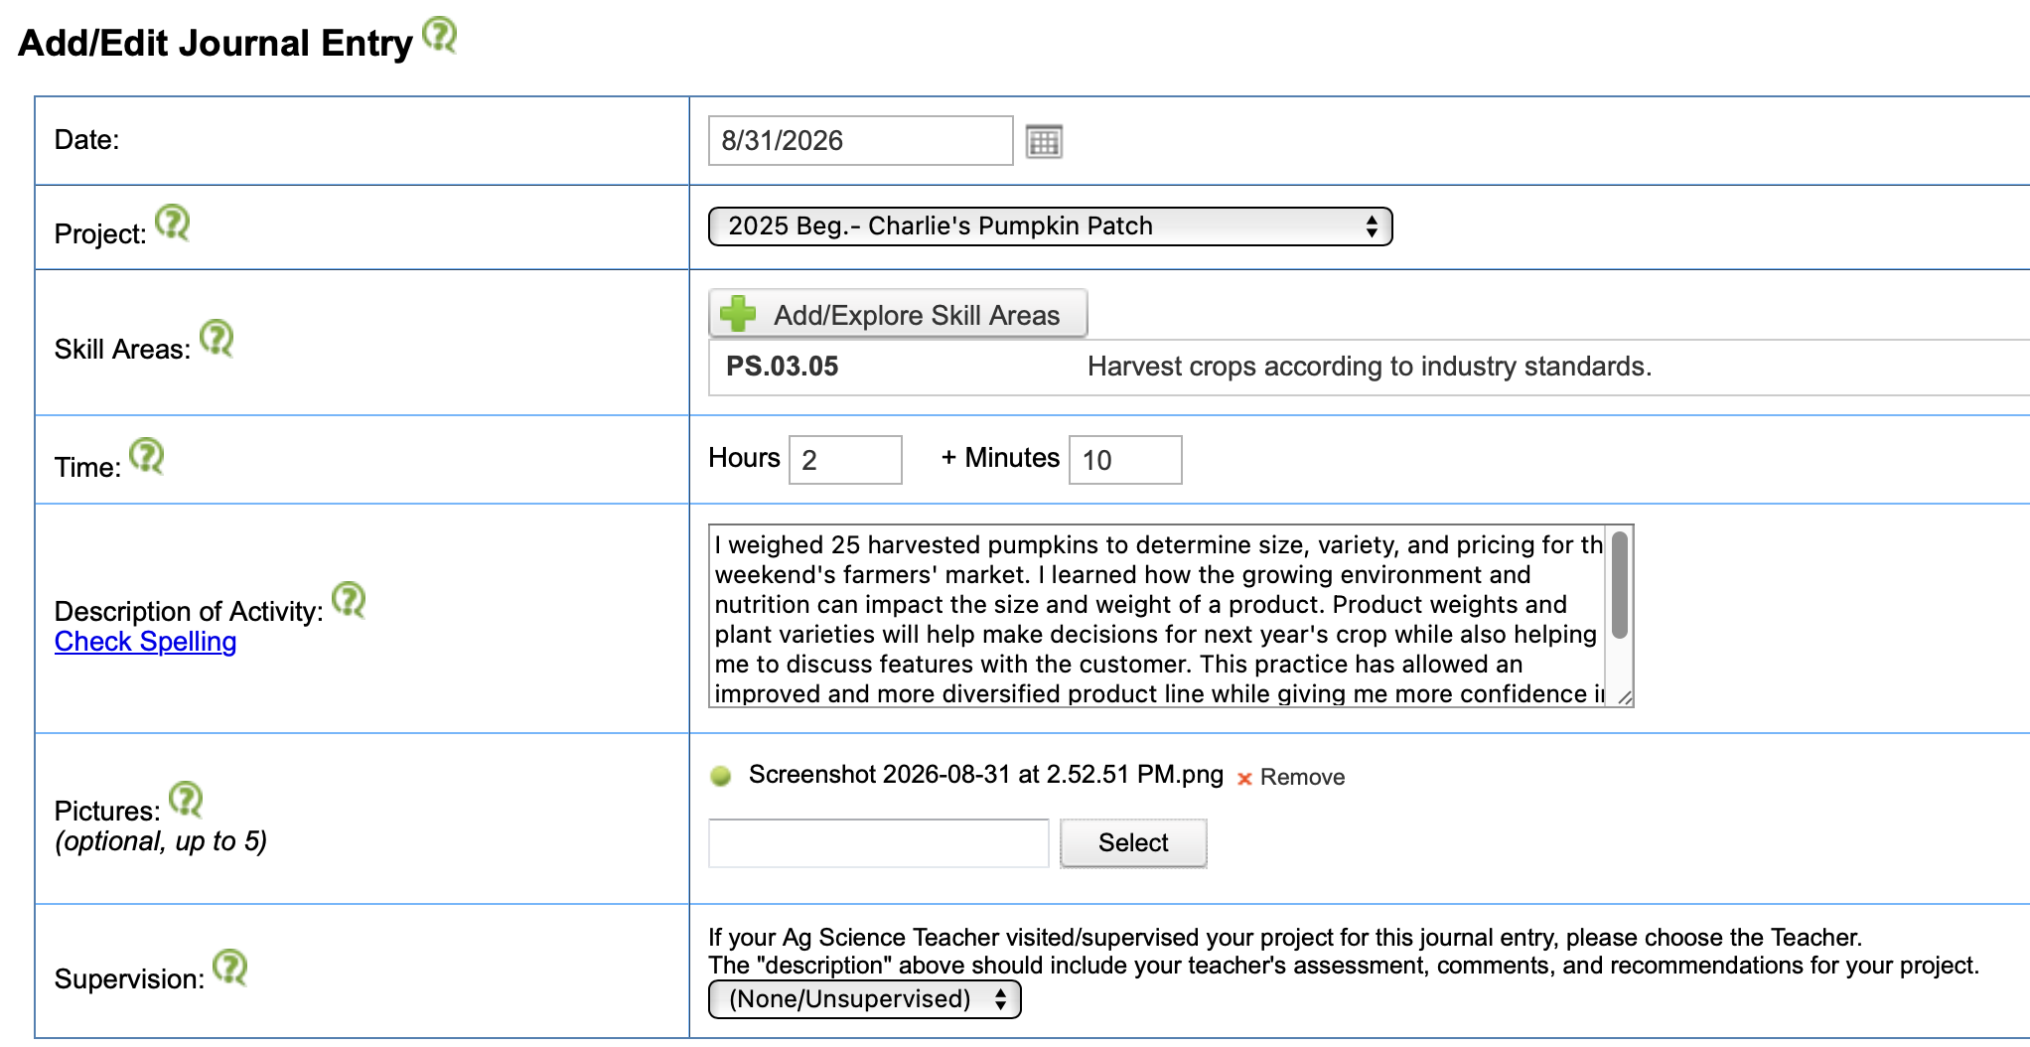

SAE - Low Quality
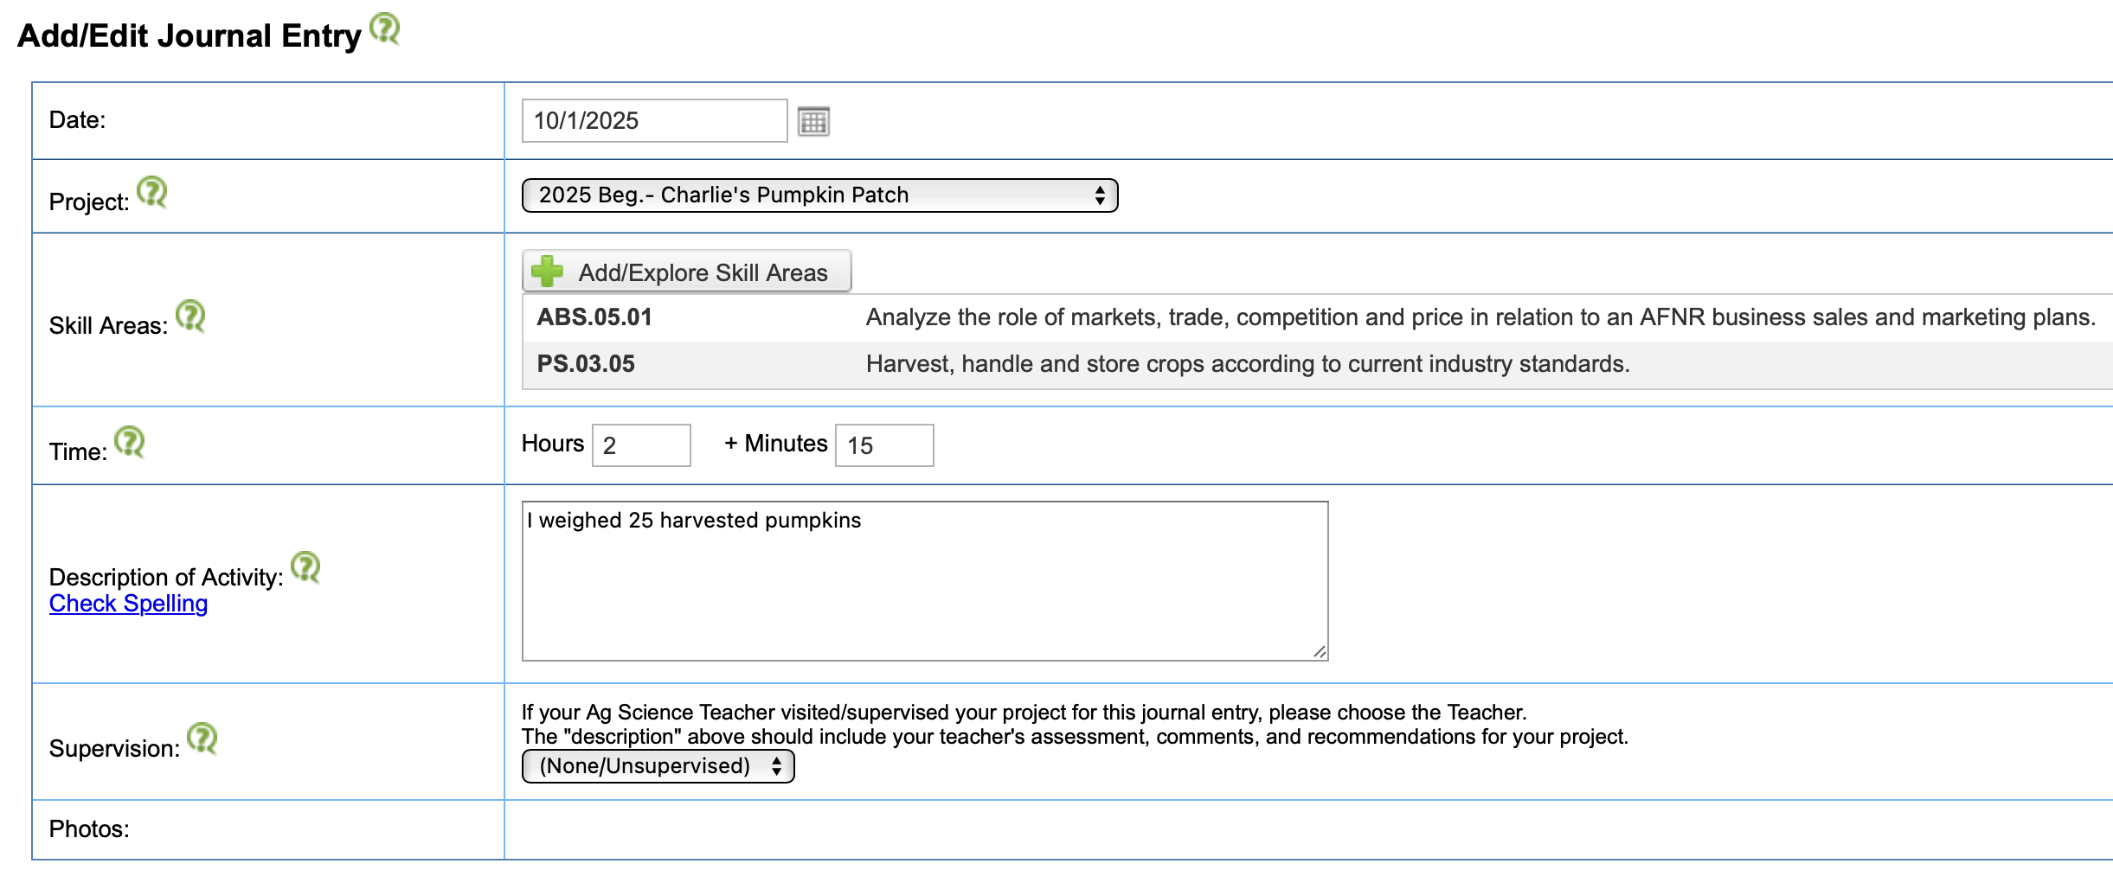

Self-Assessment Checklist - ATTACHMENT 2
Entry: Task:_________________________________________________________
ALL ____ Date: Record date activity was performed
TIP: Use your AET Calendar to locate FFA Activities and Competitions 
**Click on event to create a journal entry/Participants/Make Entry Here

FFA ____ Category: Select one from dropdown to reflect the activity accurately
Other Related FFA Activity
FFA Office Activity
FFA Competition Activity
Program of Activity Committee Activity
Community Service Activity
Parli Law, Speech, Other Activity
Career Preparation Activity

FFA ____ Activity: Name of event accurately reflects that in chapter calendar and event

FFA ____ Type: Identify specific kind of competition or event found in the dropdown menu

FFA ____ Level: Choose the level local to national from the dro]pdown Menu

SAE ____ Project: Select SAE from dropdown menu of active SAE Projects
C. Service ____ Group Served: Enter the name of the organization served in the activity
ALL ____ Skill Area: Select a skill area from the state or national content standards
Students should select a competency from your state or national content standards that most accurately relates to the work performed in the activity journaled.

ALL ____ Activity Description: In complete sentences, write a reflection that includes what was involved in the activity, your roles and results, and any specifics that support learning and reflecting.
ALL ____ Time: Enter your hours and minutes involved in the activity on that date
____ Photos: Document your activity with action photos that support your work
Upload evidence of your participation in FFA and Community Service Activities as well as photos that capture your work in your SAE. Tip: Include action shots with your face seen and PPE when applicable.

